Name – Kiranpal Singh

Roll No - RKM018B45

Section – KM018 – INT219

Question 1:

Roll Number – 45



Solution:

My HTML Code

<!DOCTYPE html>

<html lang="en">

<head>

    <meta charset="UTF-8">

    <meta http-equiv="X-UA-Compatible" content="IE=edge">

    <meta name="viewport" content="width=device-width, initial-scale=1.0">

    <link rel="stylesheet" href="style.css">

    <link href="https://cdn.jsdelivr.net/npm/bootstrap@5.0.2/dist/css/bootstrap.min.css" rel="stylesheet">

    <title>Document</title>

    <style>

        html {

            font-size: 20px;

            font-weight: 400;

            line-height: 1.125;

            color: #202011;

            font-family: Arial, Helvetica, sans-serif;

        }

        #main-body{

            position: relative;

            height: 500px;

        }

        #left-body{

            position: absolute;

            top: 150px;

            left: 150px;

            width: 500px;

        }

        #right-body {

            position: absolute;

            top: 60px;

            right: 110px;

        }

        #image1{

            height: 450px;

            width: 500px;

        }

        #title-bar{

            position: relative;

            height: 70px;

            padding-top: 15px;

        }

        #site-name{

            position: absolute;

            left: 50px;

        }

        #navigation-items {

            position: absolute;

            right: 300px;

        }

        .navigation-item-single {

            padding: 10px;

            color: #7f859d;

            font-weight: 600;

            font-size: 15px;

        }

        .navigation-item-single:hover {

            padding: 9px;

            color: #5f76d3;

            font-weight: 700;

            font-size: 15px;

            cursor: pointer;

        }

        .site-heading{

            font-weight: bolder;

            font-size: 30px;

        }

        .myBtn {

            color: white;

            font-weight: 500;

        }

        #lines-div {

            position: relative;

            height: 30px;

        }

        #line1 {

            width: 40px;

            height: 2px;

            left: 5px;

            position: absolute;

        }

        #line2 {

            width: 20px;

            left: 50px;

            height: 2px;

            position: absolute;

        }

        #line3 {

            width: 5px;

            left: 75px;

            height: 2px;

            position: absolute;

        }

    </style>

</head>

<body>

    <div id="title-bar">

        <div id="site-name">

            <span class="site-heading" style="color: #15d0b9;">Dream</span>

            <span class="site-heading" style="color: #27c645;">Upper</span>

        </div>

        <span id="navigation-items">

            <span class="navigation-item-single">Home</span>

            <span class="navigation-item-single">About</span>

            <span class="navigation-item-single">Services</span>

            <span class="navigation-item-single">Team</span>

            <span class="navigation-item-single">News</span>

        </span>

    </div>

    <div id="main-body">

        <div id="left-body">

            <div id="lines-div">

                <hr id="line1" style="color: #15d0b9;">

                <hr id="line2" style="color: #27c645;">

                <hr id="line3" style="color: #15d0b9;">

            </div>

            <h1>Start up your</h1>

            <h1>dream</h1>

            <p>Create your own business with our company. We will

                help you to make your dream true in several ways.

            </p>

            <button  class= "btn myBtn" style="background-color: #15d0b9;">Start Now</button>

            <button class="btn myBtn" style="background-color: #27c645;">Learn More</button>

        </div>

        <div id="right-body">

            <img id="image1" src="bodypic.PNG" alt="">

        </div>

    </div>

    <script src="https://ajax.googleapis.com/ajax/libs/jquery/3.6.0/jquery.min.js"></script>

    <script src="https://maxcdn.bootstrapcdn.com/bootstrap/3.4.1/js/bootstrap.min.js"></script>

    <script src="index.js"></script>

</body>

</html>

My Output Screenshot for Question 1:



Question 2. Create the following table using jQuery. The colors in different cells must be filled using jQuery only.

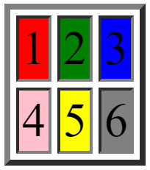

Solution:

My HTML Code:

<!DOCTYPE html>

<html lang="en">

<head>

    <meta charset="UTF-8">

    <meta http-equiv="X-UA-Compatible" content="IE=edge">

    <meta name="viewport" content="width=device-width, initial-scale=1.0">

    <link rel="stylesheet" href="style.css">

    <link href="https://cdn.jsdelivr.net/npm/bootstrap@5.0.2/dist/css/bootstrap.min.css" rel="stylesheet">

    <title>Document</title>

    <style>

        body{margin: 100px;}

        p{margin-top: 10px;margin-bottom: 10px;}

        html {

            color: #202011;

            font-size: 100px;

            font-family: Arial, Helvetica, sans-serif;

            text-align: center;

        }

        table, td {

            border: 2px solid black;

            padding: 5px;

        }

        td{

            height: 200px;

            padding: 30px;

        }

        table {

            border-spacing: 10px;

        }

    </style>

</head>

<body>

    <table style="width:60%">

        <tr>

          <td id="cell1">1</td>

          <td id="cell2">2</td>

          <td id="cell3">3</td>

        </tr>

        <tr>

          <td id="cell4">4</td>

          <td id="cell5">5</td>

          <td id="cell6">6</td>

        </tr>

      </table>

    <script src="https://ajax.googleapis.com/ajax/libs/jquery/3.6.0/jquery.min.js"></script>

    <script src="https://maxcdn.bootstrapcdn.com/bootstrap/3.4.1/js/bootstrap.min.js"></script>

    <script>

       $("#cell1").css({

           "background-color":"red"

       })

       $("#cell2").css({

           "background-color":"green"

       })

       $("#cell3").css({

           "background-color":"blue"

       })

       $("#cell4").css({

           "background-color":"pink"

       })

       $("#cell5").css({

           "background-color":"yellow"

       })

       $("#cell6").css({

           "background-color":"gray"

       })

    </script>

</body>

</html>

My Output Screenshot for Problem 2:

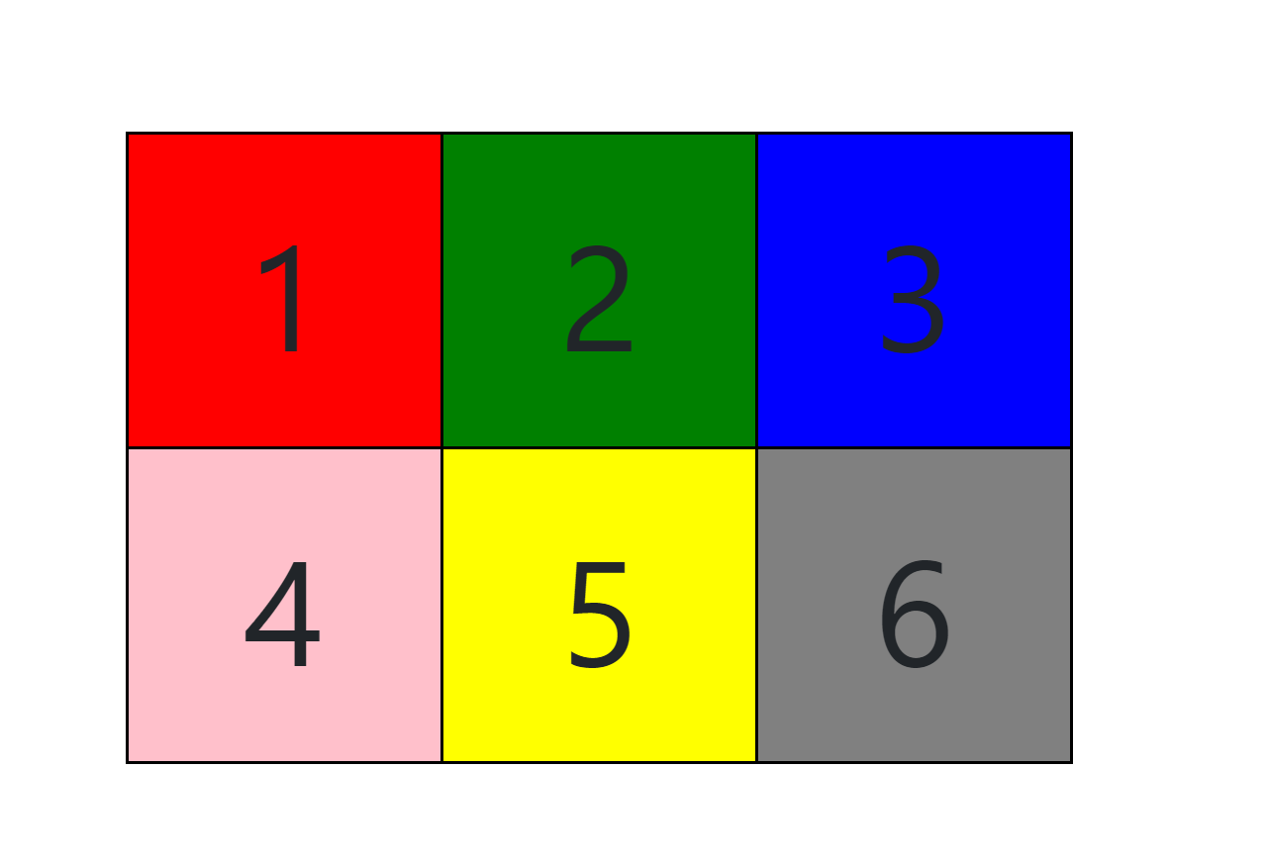

Question 3. Insert a button inside a div. Use jQuery to rotate the div upon the click of a button with a transition duration of 2s

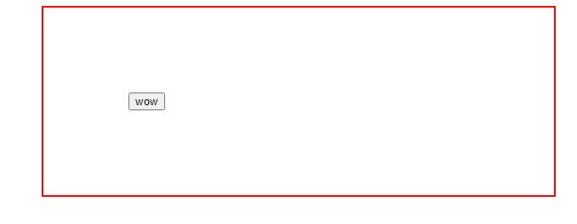

Solution:

My HTML Code for problem 3

<!DOCTYPE html>

<html lang="en">

<head>

    <meta charset="UTF-8">

    <meta http-equiv="X-UA-Compatible" content="IE=edge">

    <meta name="viewport" content="width=device-width, initial-scale=1.0">

    <link rel="stylesheet" href="style.css">

    <link href="https://cdn.jsdelivr.net/npm/bootstrap@5.0.2/dist/css/bootstrap.min.css" rel="stylesheet">

    <title>Document</title>

    <style>

        body{margin: 30px;}

        p{margin-top: 10px;margin-bottom: 10px;}

        html {

            font-size: 20px;

            font-weight: 400;

            line-height: 1.125;

            color: #202011;

            font-family: Arial, Helvetica, sans-serif;

        }

        div{

            margin: 200px 50px;

            padding: 50px;

            border: 3px solid rgb(221, 66, 66);

            border-radius: 5px;

        }

        button{

            display: block;

            margin: 0 auto;

            height: 50px;

            width: 100px;

            border-radius: 5px;

            border: 3px solid rgb(66, 63, 63);

        }

    </style>

</head>

<body>

    <div id="div1">

        <button id="button1">

            Wow

        </button>

    </div>

    <script src="https://ajax.googleapis.com/ajax/libs/jquery/3.6.0/jquery.min.js"></script>

    <script src="https://maxcdn.bootstrapcdn.com/bootstrap/3.4.1/js/bootstrap.min.js"></script>

    <script>

        $("#button1").on("click",function(){

            $("#div1").css({

                "transform": "rotate(720deg)",

                "transitionDuration" : "2s"

            });

        });

    </script>

</body>

</html>

My Output Screenshot before click:

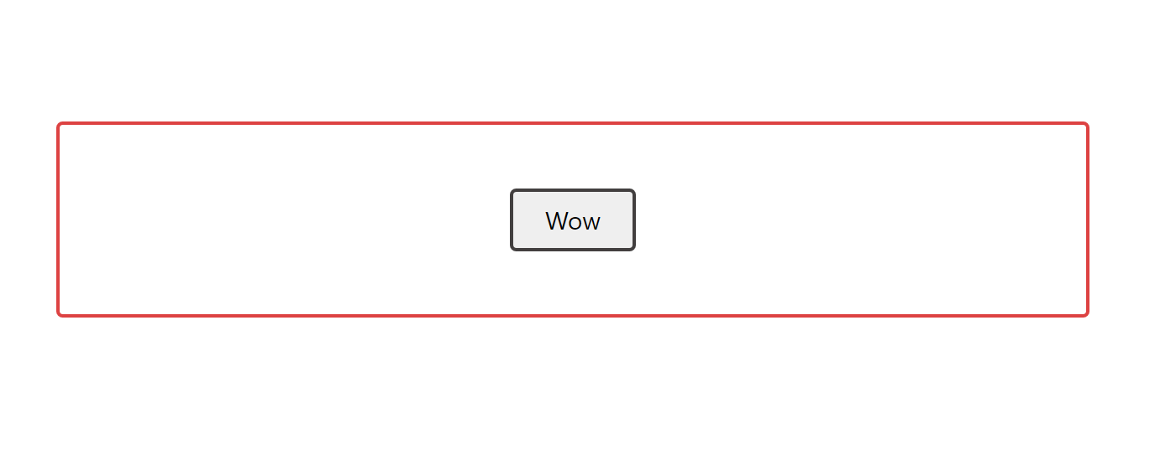

My Output Screenshot after clicking (during two seconds of transition duration)

